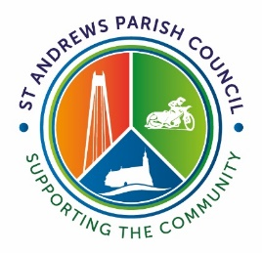 | ST ANDREWS PARISH COUNCIL  Redhouse Community Centre, Frankel Avenue, Swindon SN25 2GY  Telephone: 07900 631 733 Email: clerk@standrews-pc.gov.uk  www.standrews-pc.gov.uk

Job Application Privacy Notice

When you apply for a vacancy at St Andrews Parish Council and have sent us your application and CV, the information you provide (personal information such as name, address, email address, phone number) will be processed and stored so that it is possible to contact you and respond to your correspondence and provide information relating to the application process and interviews. Your personal information will not be shared with any third party. The Council therefore require your agreement to the below:

I agree that I have read and understand St Andrews Parish Council Privacy Notice. I agree by signing below that the Council may process my personal information for providing information and corresponding with me.

I agree that St Andrews Parish Council can keep my contact information data for an undisclosed time or until I request its removal.

I have the right to request modification on the information that you keep on record.

I have the right to withdraw my consent and request my details are removed from your database.

Name
Date of Birth if under 18
Parental/Guardian Consent for any data processing activity
Address
Emails Address
Signature
Date

